**Kronecker-Capelli Theorem**

**Gaussian Elimination**

**Kronecker-Capelli Theorem**

The general system of linear equations has a solution if the rank of A is equal to the rank of A1, and has no solution if the rank of A is less than the rank of A1.

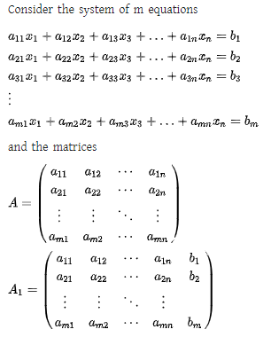

In [linear algebra](https://www.duhoctrungquoc.vn/wiki/en/Linear_algebra), the **Rouché–Capelli theorem** determines the number of [solutions](https://www.duhoctrungquoc.vn/wiki/en/Solution_set) for a [system of linear equations](https://www.duhoctrungquoc.vn/wiki/en/System_of_linear_equations), given the [rank](https://www.duhoctrungquoc.vn/wiki/en/Rank_(linear_algebra)) of its [augmented matrix](https://www.duhoctrungquoc.vn/wiki/en/Augmented_matrix) and [coefficient matrix](https://www.duhoctrungquoc.vn/wiki/en/Coefficient_matrix). The theorem is variously known as the:

* **Kronecker–Capelli theorem** in [Austria](https://www.duhoctrungquoc.vn/wiki/en/Austria), [Poland](https://www.duhoctrungquoc.vn/wiki/en/Poland), [Romania](https://www.duhoctrungquoc.vn/wiki/en/Romania) and [Russia](https://www.duhoctrungquoc.vn/wiki/en/Russia);
* **Rouché–Capelli theorem** in [English speaking countries](https://www.duhoctrungquoc.vn/wiki/en/English_speaking_countries), [Italy](https://www.duhoctrungquoc.vn/wiki/en/Italy) and [Brazil](https://www.duhoctrungquoc.vn/wiki/en/Brazil);
* **Rouché–Frobenius theorem** in [Spain](https://www.duhoctrungquoc.vn/wiki/en/Spain) and many countries in [Latin America](https://www.duhoctrungquoc.vn/wiki/en/Latin_America);
* **Frobenius theorem** in the [Czech Republic](https://www.duhoctrungquoc.vn/wiki/en/Czech_Republic) and in [Slovakia](https://www.duhoctrungquoc.vn/wiki/en/Slovakia).
* **Rouché–Fontené theorem** in [France](https://www.duhoctrungquoc.vn/wiki/en/France);

**Formal Statement:**

A system of linear equations with *n* variables has a solution [if and only if](https://www.duhoctrungquoc.vn/wiki/en/If_and_only_if) the [rank](https://www.duhoctrungquoc.vn/wiki/en/Rank_(linear_algebra)) of its [coefficient matrix](https://www.duhoctrungquoc.vn/wiki/en/Coefficient_matrix) *A* is equal to the rank of its augmented matrix [*A*|*b*]. If there are solutions, they form an [affine subspace](https://www.duhoctrungquoc.vn/wiki/en/Affine_subspace) of **{\displaystyle \mathbb {R} ^{n}}Rn** of dimension *n* − rank(*A*). In particular:

* If *n* = rank(*A*), the solution is unique,
* Otherwise there are infinitely many solutions.

**Example**

Consider the system of equations

*x* + *y* + 2*z* = 3,

*x* + *y* + *z* = 1,

2*x* + 2*y* + 2*z* = 2.

The coefficient matrix is

{\displaystyle A={\begin{bmatrix}1&1&2\\1&1&1\\2&2&2\\\end{bmatrix}},}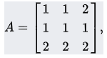

and the augmented matrix is

{\displaystyle (A|B)=\left[{\begin{array}{ccc|c}1&1&2&3\\1&1&1&1\\2&2&2&2\end{array}}\right].}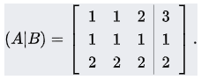

Since both of these have the same rank, namely 2, there exists at least one solution; and since their rank is less than the number of unknowns, the latter being 3, there are infinitely many solutions.

In contrast, consider the system

*x* + *y* + 2*z* = 3,

*x* + *y* + *z* = 1,

2*x* + 2*y* + 2*z* = 5.

The coefficient matrix is

{\displaystyle A={\begin{bmatrix}1&1&2\\1&1&1\\2&2&2\\\end{bmatrix}},}

and the augmented matrix is

{\displaystyle (A|B)=\left[{\begin{array}{ccc|c}1&1&2&3\\1&1&1&1\\2&2&2&5\end{array}}\right].} 

In this example the coefficient matrix has rank 2, while the augmented matrix has rank 3; so this system of equations has no solution. Indeed, an increase in the number of linearly independent columns has made the system of equations inconsistent.

**Gaussian Elimination**

In mathematics, **Gaussian elimination**, also known as **row reduction**, is an [algorithm](https://www.duhoctrungquoc.vn/wiki/en/Algorithm) for solving [systems of linear equations](https://www.duhoctrungquoc.vn/wiki/en/Systems_of_linear_equations). It consists of a sequence of operations performed on the corresponding [matrix](https://www.duhoctrungquoc.vn/wiki/en/Matrix_(mathematics)) of coefficients. This method can also be used to

* Compute the [rank](https://www.duhoctrungquoc.vn/wiki/en/Rank_(linear_algebra)) of a matrix,
* The [determinant](https://www.duhoctrungquoc.vn/wiki/en/Determinant) of a [square matrix](https://www.duhoctrungquoc.vn/wiki/en/Square_matrix), and
* The inverse of an [invertible matrix](https://www.duhoctrungquoc.vn/wiki/en/Invertible_matrix).

The method is named after [Carl Friedrich Gauss](https://www.duhoctrungquoc.vn/wiki/en/Carl_Friedrich_Gauss) (1777–1855) although some special cases of the method—albeit presented without proof—were known to [Chinese mathematicians](https://www.duhoctrungquoc.vn/wiki/en/Chinese_mathematics) as early as circa 179 CE.

To perform row reduction on a matrix, one uses a sequence of [elementary row operations](https://www.duhoctrungquoc.vn/wiki/en/Elementary_row_operations) to modify the matrix until the lower left-hand corner of the matrix is filled with zeros, as much as possible. There are three types of elementary row operations:

* Swapping two rows,
* Multiplying a row by a nonzero number,
* Adding a multiple of one row to another row. (subtraction can be achieved by multiplying one row with -1 and adding the result to another row)

Using these operations, a matrix can always be transformed into an [upper triangular matrix](https://www.duhoctrungquoc.vn/wiki/en/Triangular_matrix), and in fact one that is in [row echelon form](https://www.duhoctrungquoc.vn/wiki/en/Row_echelon_form). Once all of the leading coefficients (the leftmost nonzero entry in each row) are 1, and every column containing a leading coefficient has zeros elsewhere, the matrix is said to be in [reduced row echelon form](https://www.duhoctrungquoc.vn/wiki/en/Reduced_row_echelon_form). This final form is unique; in other words, it is independent of the sequence of row operations used.

For example, in the following sequence of row operations (where two elementary operations on different rows are done at the first and third steps), the third and fourth matrices are the ones in row echelon form, and the final matrix is the unique reduced row echelon form.

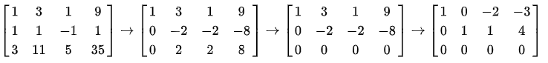{\displaystyle {\begin{bmatrix}1&3&1&9\\1&1&-1&1\\3&11&5&35\end{bmatrix}}\to {\begin{bmatrix}1&3&1&9\\0&-2&-2&-8\\0&2&2&8\end{bmatrix}}\to {\begin{bmatrix}1&3&1&9\\0&-2&-2&-8\\0&0&0&0\end{bmatrix}}\to {\begin{bmatrix}1&0&-2&-3\\0&1&1&4\\0&0&0&0\end{bmatrix}}}

Using row operations to convert a matrix into reduced row echelon form is sometimes called **Gauss–Jordan elimination**. In this case, the term *Gaussian elimination* refers to the process until it has reached its upper triangular, or (unreduced) row echelon form. For computational reasons, when solving systems of linear equations, it is sometimes preferable to stop row operations before the matrix is completely reduced.

### Example of the algorithm

Suppose the goal is to find and describe the set of solutions to the following [system of linear equations](https://www.duhoctrungquoc.vn/wiki/en/System_of_linear_equations):

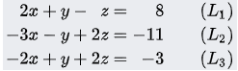

The table below is the row reduction process applied simultaneously to the system of equations and its associated [augmented matrix](https://www.duhoctrungquoc.vn/wiki/en/Augmented_matrix). In practice, one does not usually deal with the systems in terms of equations, but instead makes use of the augmented matrix, which is more suitable for computer manipulations. The row reduction procedure may be summarized as follows: eliminate *x* from all equations below *L*1, and then eliminate *y* from all equations below *L*2. This will put the system into [triangular form](https://www.duhoctrungquoc.vn/wiki/en/Triangular_form). Then, using back-substitution, each unknown can be solved for.

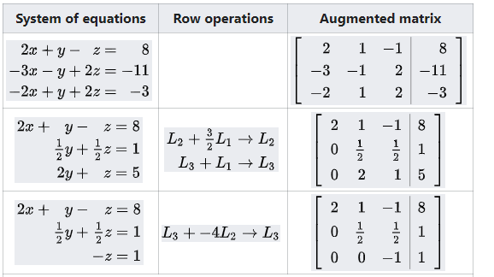

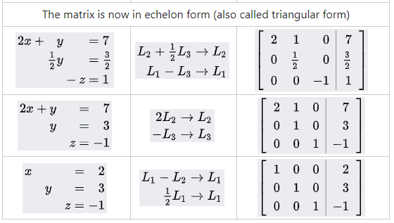

The second column describes which row operations have just been performed. So for the first step, the *x* is eliminated from *L*2 by adding 3/2*L*1 to *L*2. Next, *x* is eliminated from *L*3 by adding *L*1 to *L*3. These row operations are labelled in the table as

{\displaystyle {\begin{aligned}L_{2}+{\tfrac {3}{2}}L_{1}&\to L_{2},\\L_{3}+L_{1}&\to L_{3}.\end{aligned}}}



Once *y* is also eliminated from the third row, the result is a system of linear equations in triangular form, and so the first part of the algorithm is complete. From a computational point of view, it is faster to solve the variables in reverse order, a process known as back-substitution. One sees the solution is *z* = −1, *y* = 3, and *x* = 2. So there is a unique solution to the original system of equations.

Instead of stopping once the matrix is in echelon form, one could continue until the matrix is in *reduced* row echelon form, as it is done in the table. The process of row reducing until the matrix is reduced is sometimes referred to as **Gauss–Jordan elimination**, to distinguish it from stopping after reaching echelon form.

## **Gauss-Jordan Method**

1. Write the augmented matrix.
2. Interchange rows if necessary to obtain a non-zero number in the first row, first column.
3. Use a row operation to get a 1 as the entry in the first row and first column.
4. Use row operations to make all other entries as zeros in column one.
5. Interchange rows if necessary to obtain a nonzero number in the second row, second column. Use a row operation to make this entry 1. Use row operations to make all other entries as zeros in column two.
6. Repeat step 5 for row 3, column 3. Continue moving along the main diagonal until you reach the last row, or until the number is zero.

The final matrix is called the reduced row-echelon form.

**Example:**

Solve the following system by the Gauss-Jordan method.

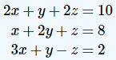

**Solution**

We write the augmented matrix.

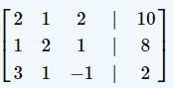

We want a 1 in row one, column one. This can be obtained by dividing the first row by 2, or interchanging the second row with the first. Interchanging the rows is a better choice because that way we avoid fractions.

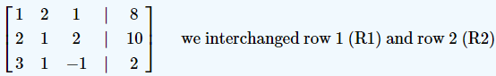

We need to make all other entries zeros in column 1. To make the entry (2) a zero in row 2, column 1, we multiply row 1 by - 2 and add it to the second row. We get,

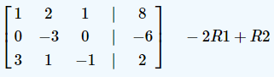

To make the entry (3) a zero in row 3, column 1, we multiply row 1 by - 3 and add it to the third row. We get,

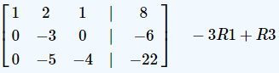

So far we have made a 1 in the left corner and all other entries zeros in that column. Now we move to the next diagonal entry, row 2, column 2. We need to make this entry (–3) a 1 and make all other entries in this column zeros. To make row 2, column 2 entry a 1, we divide the entire second row by –3.

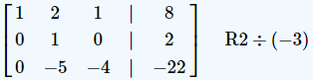

Next, we make all other entries zeros in the second column.

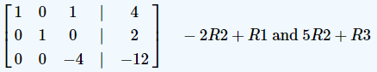

We make the last diagonal entry a 1, by dividing row 3 by – 4.

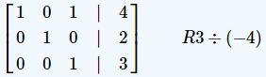

Finally, we make all other entries zeros in column 3.

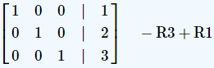

Clearly, the solution reads x=1, y=2, and z=3.

**Example**

Use Gauss-Jordan elimination to solve the system:

**1.**



**Solution:**

The augmented matrix of the system is:

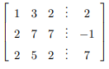

Then

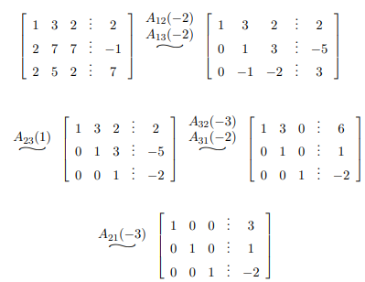

Therefore the solution of the system is x = 3, y = 1, z = −2.

**2.**

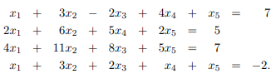

**Solution:**

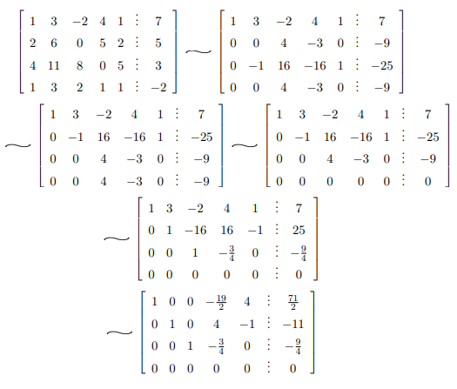

So the solution can be written as:

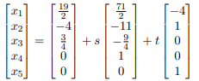

**Programming (C/C++)**

* **Solving System of Linear Equations:**Gauss-Jordan Elimination Method can be used for finding the solution of a systems of linear equations which is applied throughout the mathematics.
* **Finding Determinant:**The Gaussian Elimination can be applied to a square matrix in order to find determinant of the matrix.
* **Finding Inverse of Matrix:**The Gauss-Jordan Elimination method can be used in determining the inverse of a square matrix.
* **Finding Ranks of Matrix:**Using reduced row echelon form, the ranks as well as bases of square matrices can be computed by Gaussian elimination method.